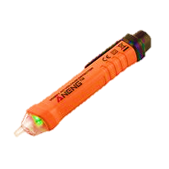

AMMAR

Fa19-bce-001

MUHAMMAD KALEEM ULLAH

Fa19-bce-007

Electronic Devices & Circuits

Engr. Shahzad Khan

Date: 28/06/2021

**COMSATs University Islamabad**

**Attock Campus**

**Wireless**

AC VOLTAGE

DETACTOR

Table of Contents

acknowledgment 2

abstract 3

INTRODUCTION 4

Required Components 4

Circuit diagram 5

Methodology 6

Working principle 6

Simulation Results 7

Conclusion 8

# acknowledgment

We would like to place on record our deep sense of gratitude to Prof. Dr. Ata Ur Rehman, Lecturer of Electrical and Computer Engineering Department, COMSATs Islamabad Attock Campus, for his generous guidance, help and useful suggestions.

We express our sincere gratitude to Sir Engr. Shahzad Khan, Lab Engineer of Electrical and Computer Engineering Department, COMSATs Islamabad Attock Campus for his stimulating guidance, continuous encouragement and supervision throughout the course of the present project.

We also wish to extend our thanks to our class mates for their insightful comments and constructive suggestions to improve the quality of this project work.

We are extremely thankful to Sir Dr. Farman Ullah, HOD Department of the Electrical and Computer Engineering for providing us infrastructural facilities to work in, without which this work would not have been possible.

# abstract

Electricity can cause serious injury or even death which is why safety must come first when working with electricity devices.

In industries accident takes place due to leakage of electricity. The accidents can be avoided by using the wireless AC voltage detector.

The motive of this project is to detect presence of electricity wirelessly. The detection takes place continuously which can be monitored by the glowing LED or by buzzer or both at the same time. Three main components are used in this project which are,

All the above components are systematically placed on the breadboard that the voltage sensor sense the voltage and make our circuit to flow current in such a way that it glows our LED or beep our buzzer, which let us know the presence of the voltage.

This concept can be used to detect any breakage in the voltage line, when we will move our sensor on the covered voltage line, it will glow the LED or turn on the buzzer till the point where there is breakage in the line and after that break point in the line it stops glowing LED.

# INTRODUCTION

The objective of this project is to reduce accident due to leakage current and voltages. It also facilitates continuous monitoring of AC lines in industries and commercial buildings so that the user gets timely alert of variations in voltage.

### Required Components

Following are the components which we have used in this project.

* 9V Battery Source
* BC547 NPN transistor
* Wire connector
* LED
* DC Buzzer
* Copper Wire
* Cutters (for copper wire)
* Breadboard
* Antenna (piece of a copper cord)
* **9V Battery Source:**

The nine-volt battery is a common size of battery that was introduced for the early transistor radios. This type is commonly used in smoke detectors, gas detectors, voltage detectors etc.

* 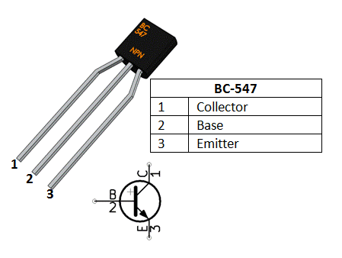**BC547**

BC547 is a NPN transistor hence the collector and emitter will be left open (Reverse biased) when the base pin is held at ground and will be closed (Forward biased) when a signal is provided to base pin. BC457 has a gain value of 110 to 800, this value determines the amplification capacity of the transistor. The maximum amount of current that could flow through the collector pin is 100mA.

* **LED**

A light-emitting diode (LED) is a semiconductor light source that emits light when current flows through it. Electrons in the semiconductor recombine with electron holes, releasing energy in the form of photons. The color of the light (corresponding to the energy of the photons) is determined by the energy required for electrons to cross the band gap of the semiconductor.

* **Breadboard**

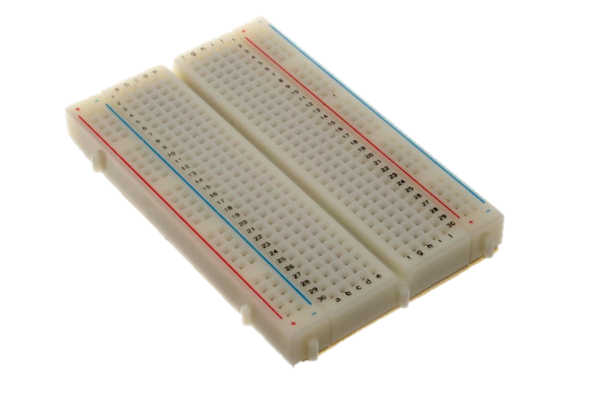A **breadboard**, or protoboard, is a construction base for [prototyping](https://en.wikipedia.org/wiki/Prototype) of [electronics](https://en.wikipedia.org/wiki/Electronic_circuit). Originally the word referred to a literal bread board, a polished piece of wood used when slicing bread. In the 1970s the **solderless breadboard** (a.k.a. **plugboard**, a terminal array board) became available and nowadays the term "breadboard" is commonly used to refer to these.

Because the solderless breadboard does not require [soldering](https://en.wikipedia.org/wiki/Soldering), it is reusable. This makes it easy to use for creating temporary prototypes and experimenting with circuit design. For this reason, solderless breadboards are also popular with students and in technological education. Older breadboard types did not have this property. A [stripboard](https://en.wikipedia.org/wiki/Stripboard) ([Veroboard](https://en.wikipedia.org/wiki/Veroboard)) and similar prototyping [printed circuit boards](https://en.wikipedia.org/wiki/Printed_circuit_board), which are used to build semi-permanent soldered prototypes or one-offs, cannot easily be reused. A variety of electronic systems may be prototyped by using breadboards, from small analog and digital circuits to complete [central processing units](https://en.wikipedia.org/wiki/Central_processing_unit) (CPUs).

* **Antenna**

Make an antenna with a small piece of copper cord which will detect the voltage signal. This antenna is being used as voltage detector.

### Circuit diagram

Circuit diagram of the project is given below

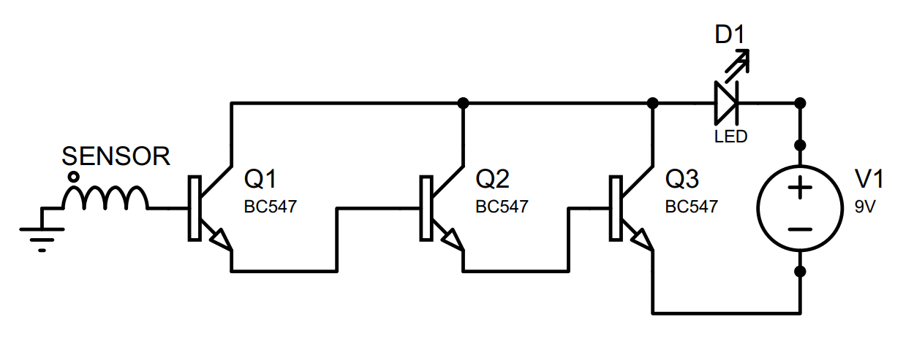

# Methodology

The circuit diagram of the project is shown above. When sensor detect any voltage it active the first transistor and that transistor eventually activate the next transistor as the emitter of the first transistor is attached to the base of the next transistor and so on.

The moment the antenna of the circuit is taken near a conductor carrying AC, the vibrations around the conductor are immediately picked up. These tiny alternating vibrations induce a corresponding current ripple into the circuit, disturbing the overall stability of the circuit. These input disturbances are instantly amplified by A1 and converted into an output voltage equal to the peak supply voltage of the circuit. The output is fed to next amplifier stage via emitter.

Following diagram is the practical implementation of the circuit diagram show above.

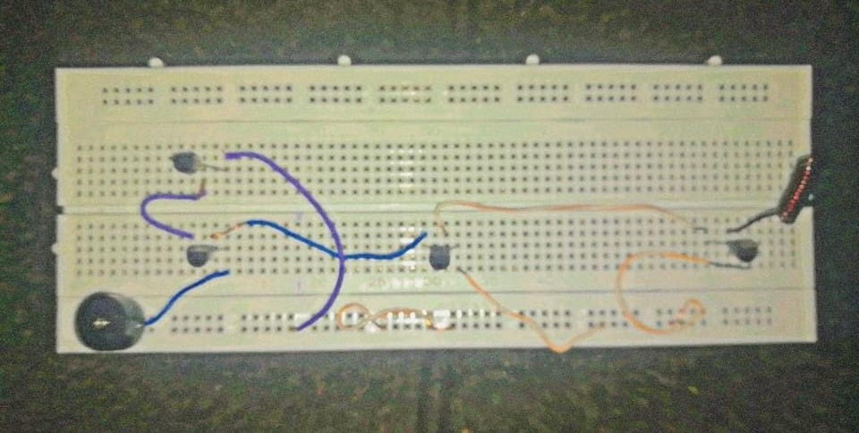

### Working principle

A [magnetic field](http://dictionary.reference.com/browse/magnetic+field) is produced around a current carrying conductor and if current through the conductor is alternating current (AC), the magnetic field produced varies periodically. A non-contact AC voltage detector detects the changing magnetic field around AC energized objects.  
 This non-contact AC voltage detector uses [NPN type transistors](https://www.jameco.com/webapp/wcs/stores/servlet/JamecoSearch?langId=-1&storeId=10001&catalogId=10001&search_type=jamecoall&freeText=2N3904) in order to detect voltage. A transistor has three terminals - collector, emitter and base. Collector to emitter current is controlled by the base current. When there is no base current, no collector to emitter current flows. Thus, a transistor acts as a switch. It can be 'ON', it can be OFF or in-between.

### Simulation Results

Simulation result of the project is shown below

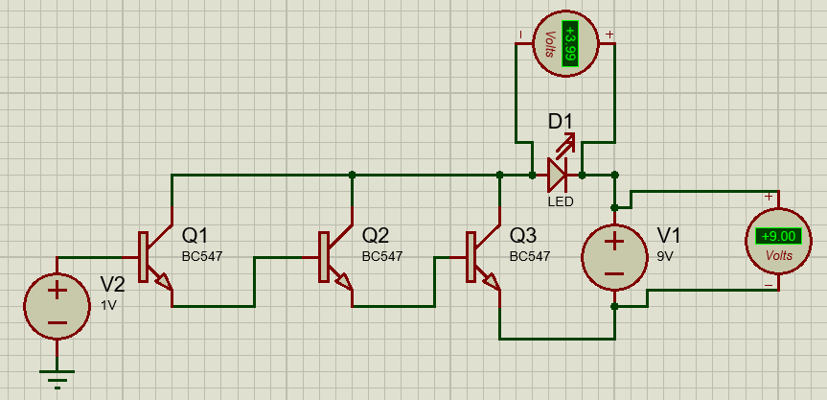

For the simulation purpose to make us analyze easy we have removed the sensor and place a voltage source of 1V here. And you can see the output across the led is about 3.99V which is glowing our led.

As the sensor detect more voltage and provide us more voltage, our LED will glow with more intensity and we can place a buzzer in the parallel too and both will start glowing and beeping.

But as mostly in such small project and sensor we detect a small amount of voltage so using only one led or only buzzer is better option to be consider.

Let us show you an interesting thing about this circuit, you can please LED in any direction like in the above simulation result the anode of the LED is connected with the common collectors point but in the following diagram we will connect this to the positive of the battery

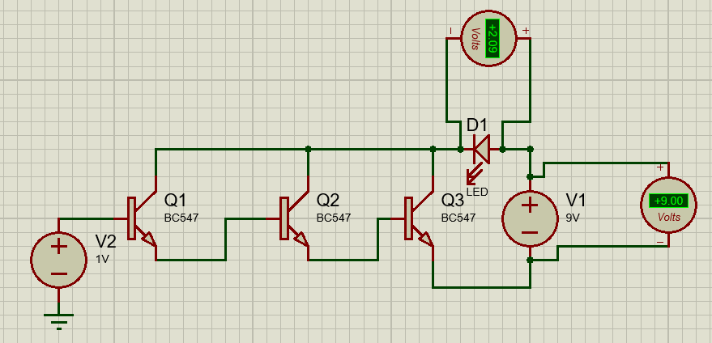

When we connect the anode of the LED to the positive terminal of the battery voltage is less as compare to when we have connected anode to the common collector. So, we can conclude if we connect the anode to the common collector the amplification of the signal is better in this condition. The amplification increases as the transistor increase in the circuit.

# Conclusion

In this project, we have proposed a wireless AC line voltage detector for preventing the leakage of power and theft of current. It is a very useful project for industrial power usage. In future, it could be extended even more for better efficiency.

After completing this project, we have learned how to:

* Work with transistor
* Determine practically active, saturation and cut off region of transistor.
* Deal with complexity of the simulation and practical implementations.
* Use of electronics concept at practical level

Following link is the main reference from which we get the idea

* [**Reference 1**](https://albrtech.com/how-to-make-non-contact-voltage-tester-wireless-ac-line-detector/)